Programming Language Research Project

Course: CST 8002-040 Programming Languages Research Project
Assignment: Research Assignment 1
Instructor: Tyler DeLay
Student Name: Qinyu Luo
Student ID: 041137796
Due Date: 09/012
Submitted: September 12

Language Research
- A survey result from Stack overflow [1]. Stack overflow is a reliable and reputable source.
- IEEE Spectrum published The Top Programming Language 2024 [2]. IEEE is reputable authority.
- The TIOBE [3] Programming Community index is an indicator of the popularity of programming languages. TIOBE Index is a reliable source.

Language Selection
I chose Server-Side JavaScript as my programming language to study. After calculating over 200+ junior programming jobs in Canada on LinkedIn, I noticed JavaScript is a very popular language. Learning more about it can boost my chance of getting a job.

Unit Testing Research
- An introduction to Unit Testing in Node.js published on AppSignal [4].
- The official docs of JEST on its website [5].
I will consider using JEST as my unit test framework, because JEST is user-friendly, comes with built-in mocking, snapshot testing and code coverage, and it is well-documented.

Development Tools: Platform, Tool availability, Licensing, Version Control
- Operating System: windows 11
- Programming Language: Server-side JavaScript v22.19.0
- IDE: Visual Studio Code 1.103.2
- Git Version: 2.45.2.windws.1

Node.js
- License: MIT License
- Status: Completely free and open-source
- Usage: Free for personal, educational, and commercial use

WBS and Gantt Chart for Practical Project Part 1
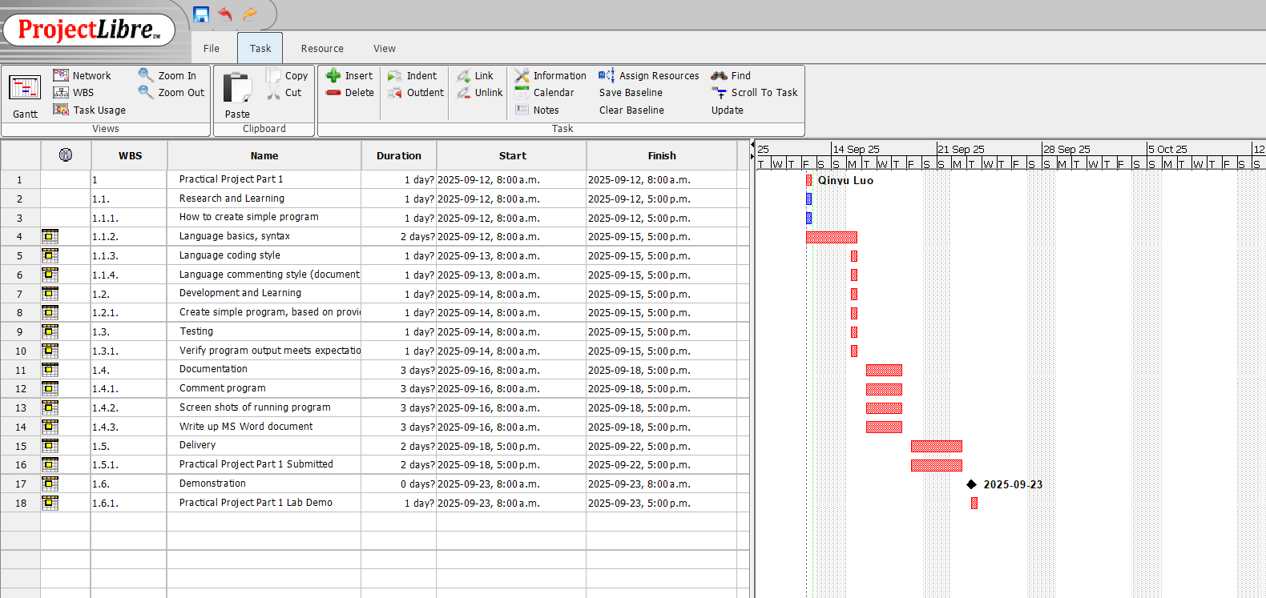

Confirmation of data set for use in the course
Dataset File Name: pacific_rim_npr_coastalmarine_intertidal_bivalves_clams_1997-2017_data.csv
Dataset Title: Site identification Year Transect Quadrat Species Common Name Count

References

[1] | Stack Exchange Inc, 2025. [Online]. Available: https://survey.stackoverflow.co/2025/technology/#most-popular-technologies. [Accessed 11 09 2025].
[2] | S. Cass, IEEE Spectrum, 22 8 2024. [Online]. Available: https://spectrum.ieee.org/top-programming-languages-2024. [Accessed 11 09 2025].
[3] | P. Jansen, TIOBE Software BV, 09 2025. [Online]. Available: https://www.tiobe.com/tiobe-index/. [Accessed 11 09 2025].
[4] | A. Zanini, 13 08 2024. [Online]. Available: https://blog.appsignal.com/2024/08/14/an-introduction-to-unit-testing-in-nodejs.html. [Accessed 11 09 2025].
[5] | S. Zaytsev, 10 06 2025. [Online]. Available: https://jestjs.io/docs/getting-started. [Accessed 11 09 2025].

